“Wild-Caught” Shrimp Dip

Ingredients:

8 oz. Cream Cheese (Organic Valley or other hormone-free brand)
1 can Tomato Soup (Amy’s Organic Low Fat Cream of Tomato)
1 packet unflavored gelatin
¾ cup organic celery, chopped finely
¾ cup organic scallions, chopped finely
2 4 ½ ounce cans of wild-caught shrimp (Wild Planet Pink Shrimp) or equivalent amount of wild-caught frozen shrimp, cleaned and thawed
1 cup of mayonnaise (Follow Your Heart Grapeseed Oil Mayonnaise)

Preparation:

- Heat tomato soup.
- Cut cream cheese into small squares and stir into the soup until it melts.
- In a separate dish, put ¼ cup of water and sprinkle gelatin over the water. Then add ¼ cup of hot water. Add this to the tomato soup and whip until creamy.
- Cool completely, stirring from time to time.
- When completely cool, add scallions, celery, shrimp and mayonnaise. Mix well.
- Add salt and pepper to taste.
- Pour into a “mold” and refrigerate.
- Serve with gluten-free crackers, organic corn chips or vegetables.

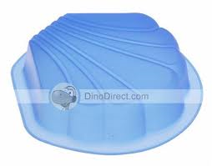
For this recipe, a seashell-shaped mold pan is nice but you can use whatever type of mold pans you have. It will also work in a simple round or square Pyrex dish.

Resources:
www.amys.com
www.organicvalley.coop
www.wildplanetfoods.com
www.followyourheart.com/products/grapeseed-vegenaise

